Write a Prolog Program to implement Towers of Hanoi.

**AIM**

To write a Prolog program to implement the Towers of Hanoi problem using recursion.

**ALGORITHM**

1. Start the program.
2. If there is only **1 disk**, move it directly from the source peg to the target peg.
3. If there are **N > 1 disks**:
   * Move N-1 disks from the source peg to the auxiliary peg.
   * Move the remaining largest disk from the source peg to the target peg.
   * Move the N-1 disks from the auxiliary peg to the target peg.
4. Repeat recursively until all disks are moved to the target peg.
5. Stop.

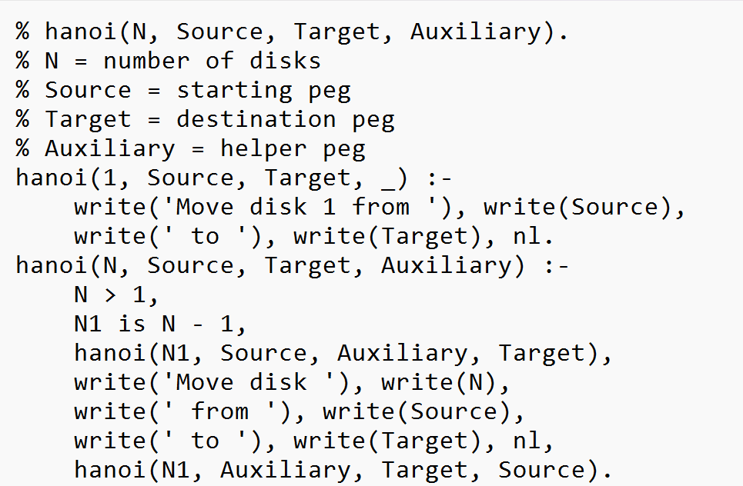

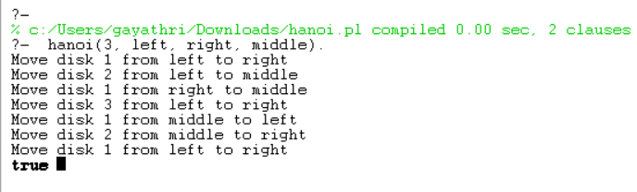

**RESULT:**

The program successfully solves the Towers of Hanoi problem by displaying the sequence of moves required to transfer N disks from the source peg to the target peg using an auxiliary peg.